Install Docker on Ubuntu 24.04
=========================================
Step 1: Update System Packages
sudo apt update
sudo apt upgrade -y
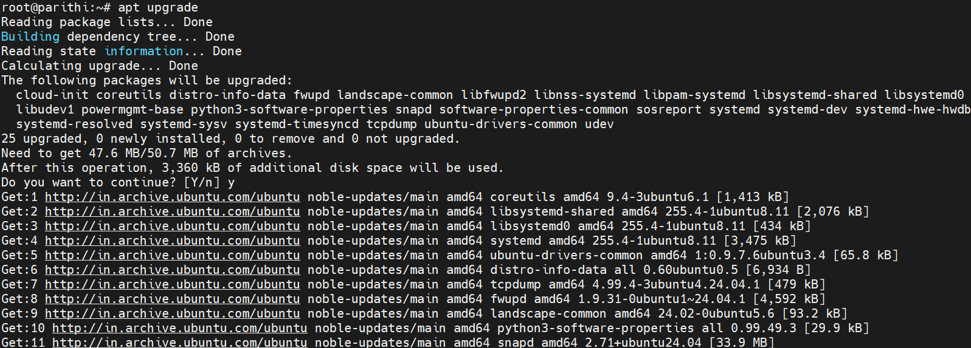
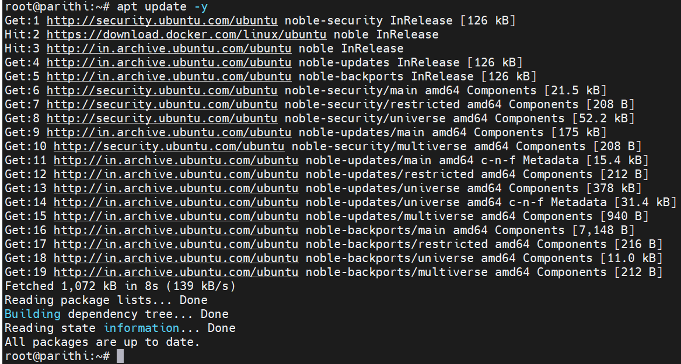
Step 2: Uninstall Old Versions (if any)
sudo apt remove docker docker-engine docker.io containerd runc
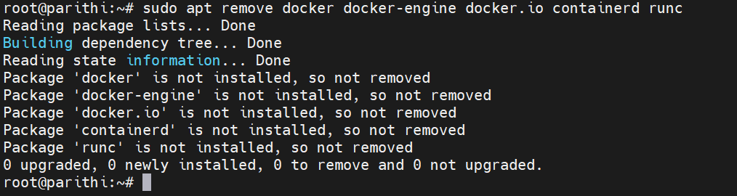
Step 3: Install Required Packages
sudo apt install -y ca-certificates curl gnupg lsb-release
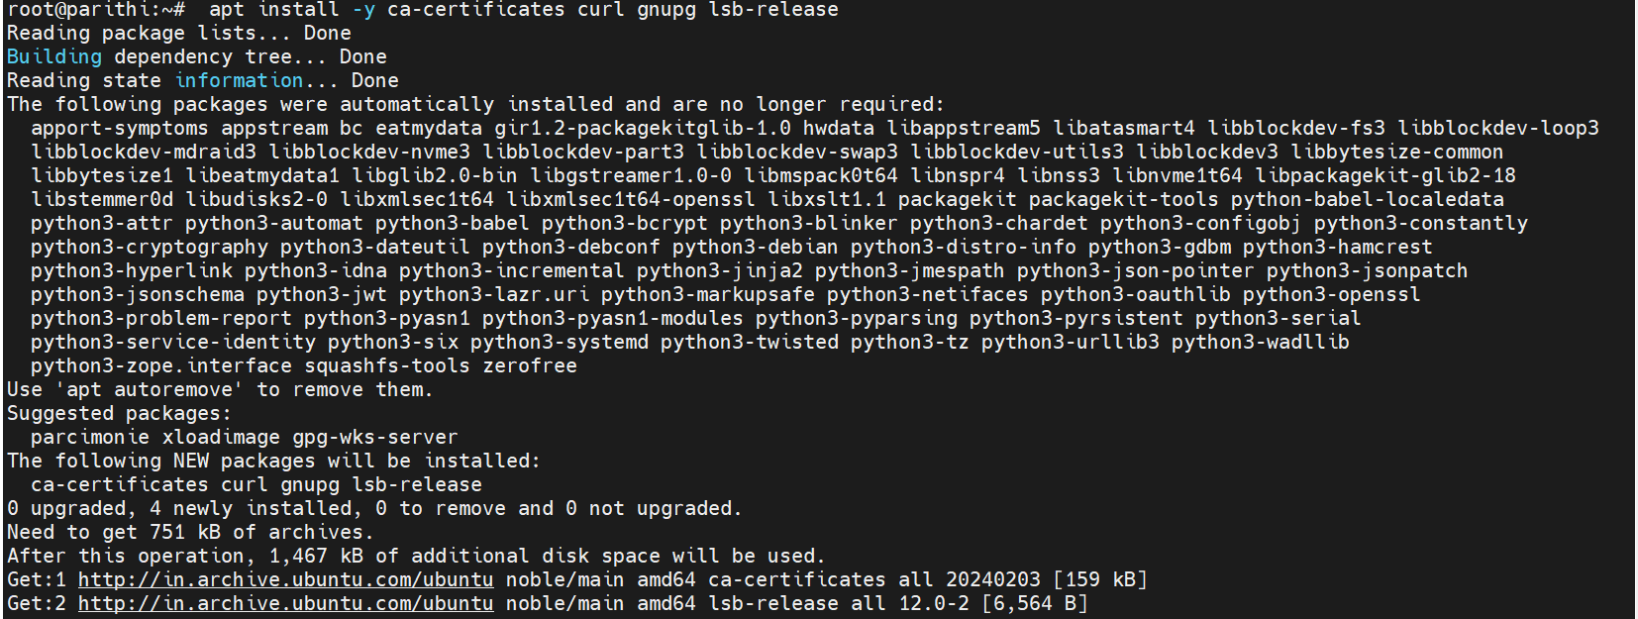
Step 4: Add Docker’s Official GPG Key
sudo install -m 0755 -d /etc/apt/keyrings
curl -fsSL https://download.docker.com/linux/ubuntu/gpg | sudo gpg --dearmor -o /etc/apt/keyrings/docker.gpg
sudo chmod a+r /etc/apt/keyrings/docker.gpg
Step 5: Add Docker Repository
echo \
"deb [arch=$(dpkg --print-architecture) signed-by=/etc/apt/keyrings/docker.gpg] \
https://download.docker.com/linux/ubuntu \
$(. /etc/os-release && echo "$VERSION_CODENAME") stable" | \
sudo tee /etc/apt/sources.list.d/docker.list > /dev/null
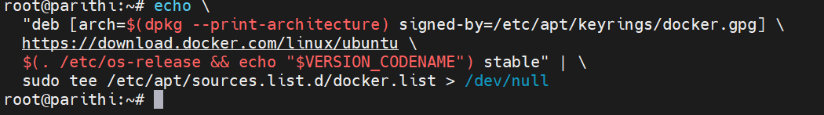

Step 6: Install Docker Engine, CLI, and Compose
sudo apt update
sudo apt install -y docker-ce docker-ce-cli containerd.io docker-buildx-plugin docker-compose-plugin
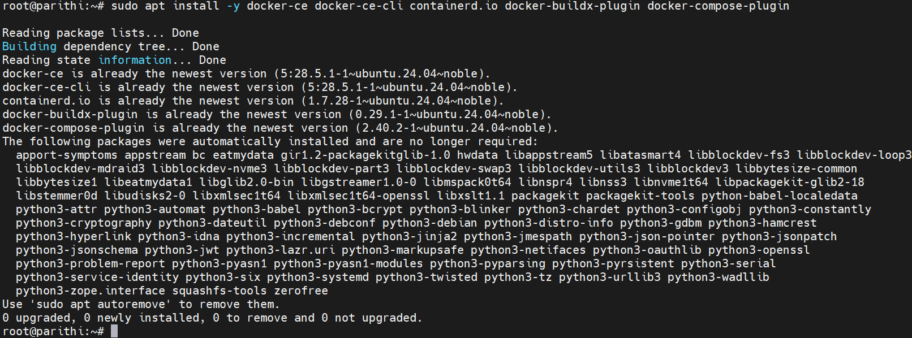
Step 7: Verify Installation
docker –version
docker compose version
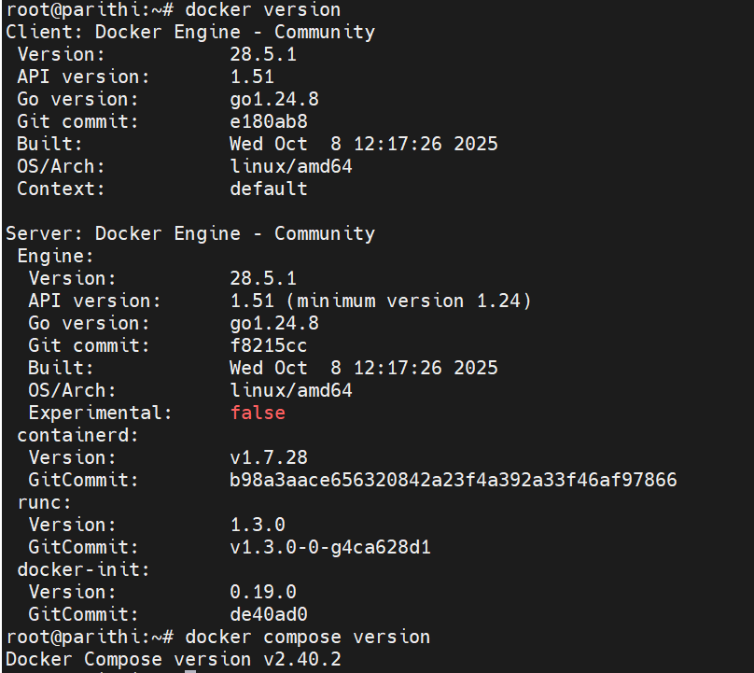
Step 8: Enable and Start Docker
sudo systemctl enable docker
sudo systemctl start docker
sudo systemctl status docker
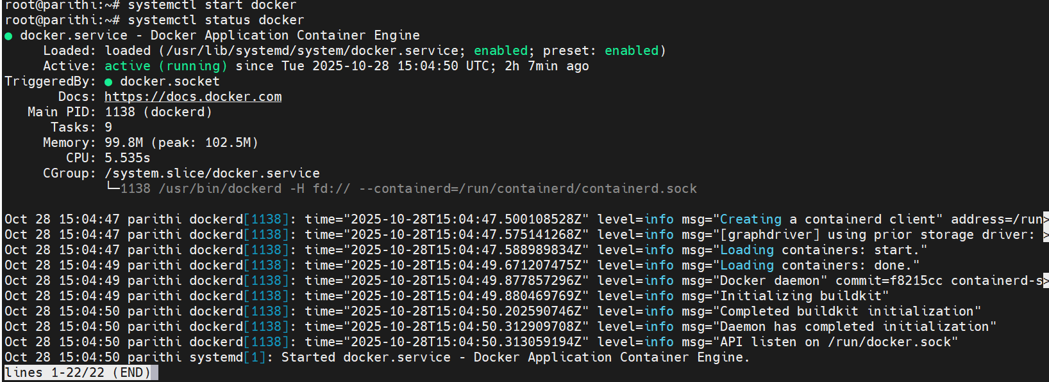
Step 9: (Optional) Run Docker Without sudo
sudo usermod -aG docker $USER
newgrp docker

Then test:
docker run hello-world
